Shuzworld – Shanghai production facility

To: Cynthia Crowninshield

**From:** Aaron Camacho, Operations Consultant

**Subject:** Shuzworld’s Recommendations & Improvements

**Date:** January 27th 2014

**Sneakers – Manufacturing method**

**Recommendation**

To better serve the purposes of Shuzworld the exact manufacturing method cannot be selected until the volume of sneakers that will be produced is defined. However, I can still provide the direction necessary to ultimately make a decision once the volume is realized. Figure 1 to the left evaluates each method and gives you the lowest cost option based on volume. Figure 2 is a graphical chart displaying each method and the points of intersection. As you will see the “Outsourcing” method is more cost effective than the other two methods when the number of units produced is between 0 and 25,000. However, as the number of units produced increases over 25,000 “Reconditioning” of the old machinery is the lowest cost method until 300,000 units are produced. Passed 300,000 units it would be more cost effective to “Purchase New” machines to produce the Zamba sneaker line. Therefore, it would be my recommendation to choose the method that best follows Zamba sneakers projected sales forecast. With out knowing the volume it is difficult to recommended a sure method. However, I would presume that more that 25,000 units will be sold thus eliminating the “Outsourcing” option and leaving reconditioning or the purchase of new equipment.

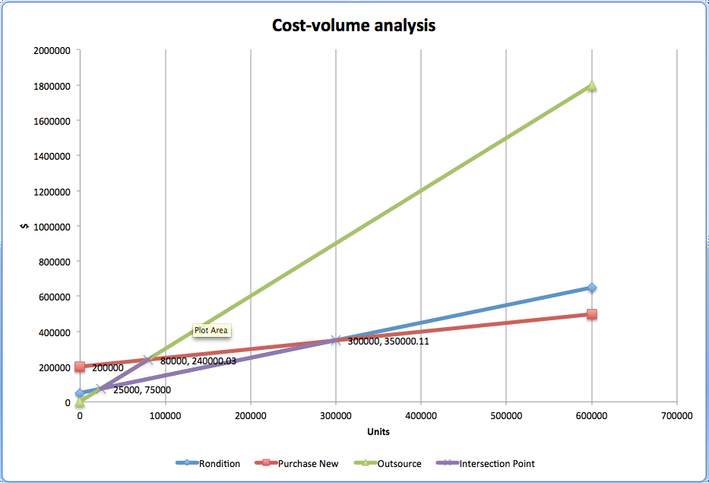

Figure 2: Cost-Volume Analysis Chart

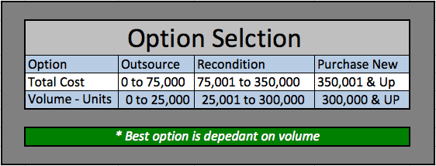

Figure 1: Option Selection

**Tool Used to Make Decision**

The decision analysis tool used to analyze the manufacturing methods available for the Zamba sneakers was “Breakeven Analysis” in Excel-OM. Its was chosen for its unique and effective method of comparing and charting different data points and possibilities; especially data points with multiple fixed and variable costs. With the graph made from the breakeven analysis I was able to decipher at which x/y axis point each method intersected thus telling me when an alternative method became a more cost effective decision. Though the analysis could be done by hand and the slope could be calculated for each set of data the margin for error would have be greatly increased resulting in a less optimal or disasters solution.

**Sales Volume Forecast – Least Squares Method**

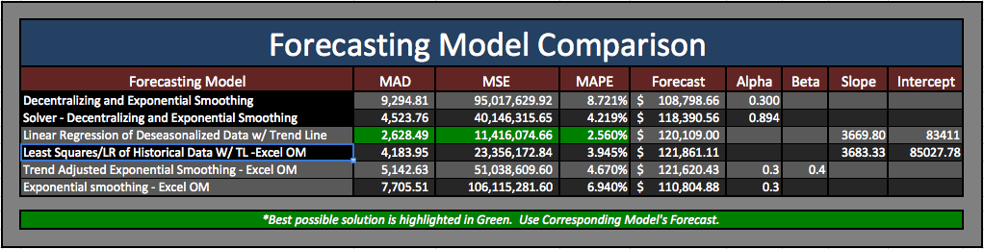The five tools I used to forecast the sales volume of the next quarter where the least squares method, Exponential smoothing with decentralization and deseasonalization, Linear regression/least squares method of the deseasonalized historical sales data, and trend adjusted exponential smoothing and exponential smoothing. Figure 3 shows the comparative results between each method with the chosen method highlighted in green.

Figure 3: Forecasting Model Comparison

When alpha and/or beta where used in the forecast, two possible scenarios were developed. One with the preferred alpha and beta provided from the scenario (alpha: 0.3 & Beta: 0.4) and one scenario with the best alpha and beta chosen by solver. The objective of solver was to minimize MAPE by choosing the best alpha and beta.

The method that resulted in the lowest MAPE, MSE, & MAD was “Linear Regression of Deseasonalized data w/ Trend Line”. For this model the historical data was put into a 2 period centered moving average and then the data was deseasonalized with calculated seasonal indices. Afterwards a trend line was calculated for the deseasonalized data and the slope equation was then used to forecast the next quarter’s sales volume. Two advantages of this method were its ability to calculate for trend and that little data was required to be accurate. However, a disadvantage to this method was it took much more work to set up all the necessary calculations than just imputing the historical data in the forecasting tool within Excel-OM. Therefore, though it did have the lowest MAPE, MSE and MAD the margin for error was higher and the time taken to forecast the next quarter was significantly longer than using an excel-OM or POM forecasting model. The difference in the MAPE, MSE, MAD and forecast in my model and the Least Squares model in Excel-OM is insignificant. If I were to do it again Excel-OM would be my method of choice on reasons of accuracy and time needed to forecast the next period’s sales volume.

**Exponential Smoothing vs. Linear Regression**

When choosing a forecasting method the forecaster must understand what the data is saying. For example, a type of questions that the forecaster might ask are, does the data have a trend and is it upwards or downwards? Or he/she might ask is there seasonality in the data, meaning at certain times of the year the data receives a spike or trough that is uncommon in the rest of the year. In retail seasonality spikes often happen around the holidays like Thanksgiving and Christmas. Not all forecasting methods or techniques are equally capable of catching trend and seasonality. And if a forecasting model cannot follow a trend or calculate for seasonality it is less likely to give you an accurate forecast.

Exponential smoothing has many advantages like it needs very little data to calculate an accurate forecast. However, when a trend is present in the data the forecast reacts less slowly than other models creating a less accurate forecast. For example, linear regression is a forecasting model that is quite good at catching and forecasting when a trend is present. When forecasting the third quarter in 2007 linear regression or least squares method the forecast was $92,394. Where as, the exponential smoothing method calculated $90,000. The actual sales for that period was $95,000 putting an absolute error of 5.26% for exponential smoothing and 2.74% for linear regression. The difference in absolute error continues throughout all the periods showing that linear regression is clearly the more accurate forecasting option for this particular set of data because there is a lower “Mean Absolute Percent Error (MAPE)” which is a result of its lower deviation from the historical data. It is important to note that another form of exponential smoothing, “exponential smoothing with trend adjustment” does follow trend well. However, with this particular data the MAPE was still lower in the linear regression.

The historical data also seemed to have some presence of seasonality shown in the spikes in the second and fourth quarters that then receded to normal sales averages that followed the trend. Because seasonality was present a seasonal index was built and used to calculate a more accurate forecast using the “linear regression of deseasonalized data w/ trend line” model. With this model the absolute error was based off of the deseasonalized data and the forecast. It did result in a lower MAPE however, if compared to the historical data it the MAPE would not have been better then the Linear Regression model based off of the historical data. With this said, it is my opinion that the seasonality, though present, is not sufficient enough to make a deseasonalized data index necessary to calculate the tenth period forecast. Therefore, I would recommend using the simple linear/least squares forecast as the best possible prediction for the sales volume in the third quarter of 2009.

**Control Chart Metrics**

Control chart metrics is a method of statistically monitoring a process for irregularities. Typically a control chart will have a low, high and medium value. The low and high values are the upper and lower limits that encapsulate the acceptable range in which a process is deemed good. The medium level is the mean or average of all value points with in the control chart. Figure 3 below is an example in which “Frito Lay” is measuring the level of salt content within its potato chips. As you will see the tan shaded area the acceptable range of salt content or the normal variation that happens because of natural causes. Anything outside the range is unacceptable and the abnormal variation is due to assignable causes.

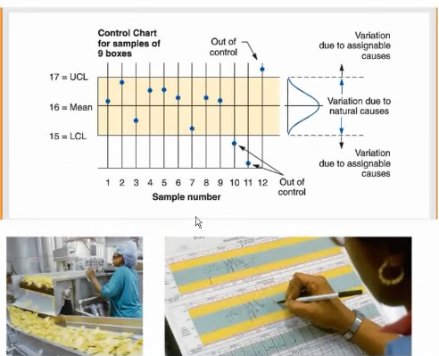

Figure 3: Frito Lay – Salt Content Control Chart (WGU, 2013)

There are six ways to tell if “a process is off target …(1) Value(s) outside of the upper and lower control limits; (2) An upward or downward trend of 5 or more consecutive points; (3) Two or more consecutive points close to the edge of the upper or lower control limits; (4) a run (consecutive) of 5 or more points above or below the center (or mean) line; (5) Too many points on one side of the center line, and; (6) Erratic behavior” (WGU, 2013). With control charts a company as a whole, assembly lines, individual machines, personal, etc. can be measured and a determination can be made whether or not the unit is working within acceptable parameters or whether the unit needs immediate attention.

**Control Chart Analysis of Shoe Sole Height Samples**

Using the “six ways to tell if a process is off target” we can quickly see that during hour 14 the dual-density rubber molding machine experienced two value points that where well above the acceptable upper control limit and one value point at hour 15 that though it was within the acceptable range limit was exceeding low compared to the other values. Also, at hour 2 the upper control limit was nearly reached by a value point. I am more concerned with hours 14 and 15. However, the erratic nature of the values at hours 2, 3, & 7 should also be noticed, though they would not be of to much concern if hours 14 and 15 where not so inconsistent. Though seeing these irregularities is a concern, more data should be collected to see if the problem persists. Continually using control charts will allow the Shanghai plant to monitor the operations of the dual-density rubber foam-molding machine and repair a malfunctioning machine before serious damage can be done to merchandise, employees or the machine itself. In this we will be able to produce a more quality product and efficiently decrease future malfunction costs.

**Control Chart Analysis of “Eyeletting Fraction Defects”**

When evaluating employees, or in this case the operators of the eyeletting machines, we are looking for performance averages on a control chart. In this case the optimal number of mistakes or defects in eyelets is zero. However, some leeway has been given for those “Opps” moments that are bond to happen. The leeway is the upper limit, which in this case is a fraction or percent of defective eyelets to non-defective eyelets.

The upper limit is 0.125 and two operators have surpassed it, operator 13 and 20. Now, it is possible that the operator had other factors that caused him/her to surpass the upper limit than just plain old negligence. However, this is why we have control charts so we can quickly tell if an employee is not performing to satisfactory standards and then we can take the appropriate measures to see if the employee had a bad day, needs to be fired, trained or have other corrections to remedy the cause of the unacceptable errors.

An investigation should be made as to why the operators were not performing within acceptable standards and appropriate corrective action on should be taken to remedy the problem. Mistakes cost time and money this is why having a control chart of employee performance is so crucial to stopping erratic behavior and processes. Control charts like the one you provided to me can also be used in other parts of the plant to measure employee performance and decrease defects and erratic processes. The first step to fixing the problems is finding where they are. Control charts help to identify problem locations whether they are influenced by mechanical or human resource means.

**References**

WGU. (2013). *JGT2 - Practice: Control Charts Examples* . Retrieved January 25, 2014, from Panopto: http://wgu.hosted.panopto.com/Panopto/Pages/Viewer/De fault.aspx?id=d00ee7c1-543a-4262-a748-dc668d259730